**VIEW**

Tekrarlana sorgularin evzine view yaradiriq.

Hemen view ni funksiya kimi cagiriq.

Viewnin adi ile tablelari update delete ede bilerik (union ve.s olmayanda)

viewin adinda ddl emeliyyatlari ede bilmerik

Viewlar virtual tablelardir.

cross join, union, union all, except, distinct, having ve group by olsa dml emeliyyatlari ede bilmerik.

Tableda property adi deyisdikde viewdaki ad problem olmasi deye

WITH SCHEMABINDING den istifade edirik.

View yarandiqad WITH SCHEMABINDING yazsaq artiq ona baglli olan tablelarin columnlarini deyise bilmerik

x

This [query](https://www.mysqltutorial.org/mysql-select-statement-query-data.aspx) returns data from both tables customers and payments using the [inner join](https://www.mysqltutorial.org/mysql-inner-join.aspx):

SELECT

customerName,

checkNumber,

paymentDate,

amount

FROM

customers

INNER JOIN

payments USING (customerNumber);

Code language: SQL (Structured Query Language) (sql)

Here is the output:

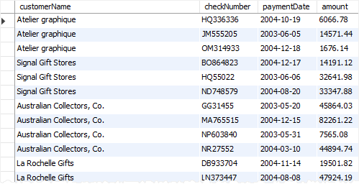

Next time, if you want to get the same information including customer name, check number, payment date, and amount, you need to issue the same query again.

One way to do this is to save the query in a file, either .txt or .sql file so that later you can open and execute it from MySQL Workbench or any other MySQL client tools.

A better way to do this is to save the query in the database server and assign a name to it. This named query is called a database view, or simply, view.

By definition, a view is a named query stored in the database catalog.